Today, you will create an interactive Mad Lib Game. **Work not saved correctly will not be graded.**

1. Write a 3 to 6 sentence story about ANYTHING you want, as long as it is school appropriate.
2. Highlight **2 adjectives**, **2 nouns**, and **2 verbs** using different colors. Highlight the word using the same color if it shows up multiple times. Note: *You story can have more blanks than required if you want.*
3. Replace each highlighted word with a placeholder: adjective1, adjective2, noun1, noun2, etc…
4. Open the Python Shell using your desktop icon. **Create and save a new file named MadLib.py in your H drive**.
5. Create a variable that prompts and stores input from the user for each blank in your story.
6. Use those variables to print your story.

See the example below:

Sample Story Highlighted:

According to all known laws of aviation, there is no way a bee should be able to fly. Its wings are too small to get its fat little body off the ground. The bee, of course, flies anyway because bees don't care what humans think is impossible.

Sample Story with Blanks:

According to all known laws of aviation, there is no way a **noun1** should be able to **verb1**. Its wings are too **adjective1** to get its fat little body off the ground. The **noun1**, of course, **verb1**s anyway because **noun1**s don't **verb2** what **noun2**s think is **adjective2**.

Sample Story created with user input:

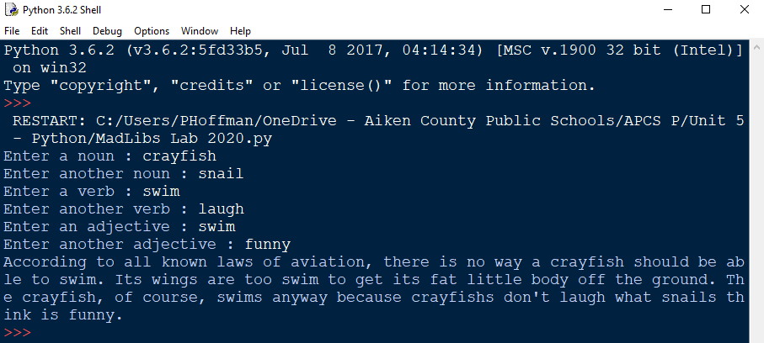

***Hint****: You may refer back to the program we created yesterday to remind yourself how to create a variable that prompts the user for input and then stores the response, as well as to remember how to print variables.*

**Rubric**

|  |  |
| --- | --- |
| Prompts and stores 6 user input values | 0 1 2 3 4 5 |
| Uses all input values in story | 0 1 2 3 4 5 |
| Story is at least 3 sentences | 0 1 2 3 4 5 |
| Story is creative and original | 0 1 2 3 4 5 |

**Bonus points** : create multiple MadLib Games, max of 5, saving them as MadLib2.py, MadLib3.py, etc…

Score : _______ / 20